Book Shop

Idea and OUTLINE

PROPOSAL

Aviral TAkkar

*Delhi Technological University*

# Basic Plan

This app is going to serve as a digital platform to enable users to purchase ‘available’ listed books by directly contacting the seller. In addition, the user may himself upload meta-data about books he wishes to sell.

**Main Components**

1. Public Market
2. User Account
3. Books uploaded for sale by user
   * **The Public Market:** This would be the home page of the app, where the user would be able to view all books available for purchase that have been uploaded by all other users using the app. For this purpose, server space would be required to create and maintain a database of users and the information about the books they have to sell. A search tab would be provided to look for specific books in the market.
   * **User Account:** To upload books to the market, a user must first create an account. The user must choose a username and password and provide his contact number and email ID (which would serve as primary key). After confirming the email address, the user’s account would be created. Once the user logs in and returns to the market, the user would not be able to view those books that have been uploaded by him, in the market.
   * **Books uploaded by the user:** To upload books, the following information would be need from the user
     + A recent photograph of the book to be sold.
     + The name and author of the book.
     + Duration for which the book has been owned
     + Rate condition of book
     + Other comments

On obtaining this information, an HTTP request would be sent to Google Books API to obtain meta-data about the book. For this purpose, the following APIs would be used, relative to the base URI: https://www.googleapis.com/books/v1

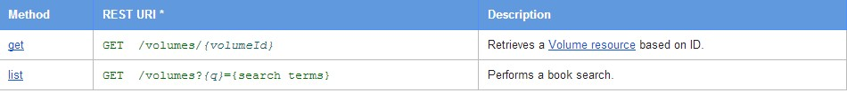

If the book is not found on Google books, then the user must provide the following additional information about the book

* Publisher
* Retail Price

The user will then quote a price to the sell the book at.

On completing this process, the book would be linked to the user’s account and uploaded to the server. The uploaded books would appear in the “My Books” tab to the user, and would appear in the global market to others.

# Operation

When a user wishes to purchase a book

1. He may browse the market and select a book he wants to purchase.
2. He may use the ‘search market’ option to look for the desired book.

Once the book has been selected, the contact information of the seller of that book would be provided to the user. It is an open choice whether to provide this information through email or make it openly available on the market.

All suggestions are welcome.